**AP COMPUTER SCIENCE A UNIT 2 PROJECT**

20 points major assessment

**Due Tuesday, November 1**

In this project, the goal is to create an interactive program that allows a user to enter a pairs of coordinate points, e.g. (4, 13) and (-3, -8), and your program will calculate and output for the user:

* The distance between the pair of points.
* The slope and *y*-intercept of the line passing through those points.
* The complete linear equation that passes through the points, e.g. *y* = 3*x* + 1.0

The user will then be asked to enter an *x* value and your program will “solve” for the corresponding *y* value and tell the user the coordinate of the point on the line with that *x*.

[**Here is a video demonstrating the program**](https://drive.google.com/file/d/1srmI4XBc7j9vToHJGYqfjhe8GxWvzVXq/view?usp=sharing)

For this project, you should implement a complete LinearEquation class with instance variables and methods outlined on the next page. You should also write a runner class (LinearEquationRunner) in which you write the logic for getting the user’s input via Scanner, etc. and calling the appropriate methods of your LinearEquation class.

Feel free to use or edit other classes or code that you have already developed in previous labs for this project. The string methods will be useful!

**Submission**

* Submit this document in Google Classroom with the self-check column on the last pages completed by you (should be all X’s)
* Complete your program in IntelliJ, push to GitHub, and share a link to your project below:

|  |
| --- |

**Program Technical Specifications**

**Your LinearEquationRunner class should hold the main “logic” of your program in the main method, including input and printed output (****see examples here****), and should include the following:**

* Use the Scanner class to welcome the user and ask the user to enter each coordinate point; both *x* and *y* values should be *integers*, i.e. your program should support user-provided points like (3, -7), but does *not* need to support decimal values like (3.5, -7.2).
* The user should be able to type in each **in coordinate form**, like this: (5, -12) with opening and closing parentheses, and a comma followed by a space in between the *x* and *y* coordinates.
* Your program should be able to take each coordinate (scanned in as a String) and “parse out” both the *x* and *y* values. You should use the Integer.parseInt static method (see slides for example) and various String methods to help with this.
* Once you have the *x* and *y* values for each of the two points parsed out of the coordinate strings provided by the user, use them to create a LinearEquation object.
* Your program should then call the lineInfo() method of the LinearEquation object to obtain and print a string that includes the following:
  + The two original points
  + The equation of the line through the two points in *y = mx + b* format
  + The slope of the line
  + The *y*-intercept of the line
  + The distance between the two points
* Lastly, after printing the line information through the two points, ask the user to enter an *x* value and have your program print the corresponding coordinate point (*x*, *y*) on the line; for example, if the equation is *y* = 3*x* + 1.0 and user enters an *x* value of 3.5, the program prints out (3.5, 11.5). Note that although the user was required to provide the initial coordinates using all integer values, the user *should* be able to provide a double value for *x* in this step (and your program should print a coordinate with doubles).
* See Full Program Examples 1 and 2 for examples of the program's output.
* **Important Note!** If the user enters two coordinates with the *same* ***x*** value, e.g. (4, 5) and (4, -6), the points fall on a *vertical* line, the slope is undefined, and there is *no valid linear equation* in the form *y = mx + b* to model this. You should check for this situation after the user enters their points, but *before* creating a LinearEquation object with the *x* and *y* values. If the user *does* do this, inform your user that they have entered coordinates that result in a vertical line and provide an equation in the form *x =* __, e.g. *x =* 4 for points (4, 5) and (4, -6), then end the program (do not print out any other information). Your LinearEquation class does *not* need to handle x1 and x2 being equal. See Full Program Example 3 for an example of the program's output for vertical lines.

**Your LinearEquation class should support the following behaviors:**

* Creating a new LinearEquation from points (*x*1, *y*1) and (*x*2, *y*2).
* Calculating and returning the distance between the two points, rounded to the *nearest hundredth*.
* Calculating and returning the slope and *y*-intercept of the linear equation containing the two (*x*, *y*) points, each rounded to the *nearest hundredth*.
* Generating and returning a printable String that represents the linear equation of the line in slope-intercept (*y* = *mx* + *b*) form, where *m* is the slope and *b* is the *y*-intercept; e.g. "y = 3x + 1.5"
  + Print *m* as a *fraction* rather than a decimal, e.g. "y = 1/2x + 1.5"
  + If the fraction reduces to a whole number, print the whole number rather than a fraction: e.g. print "y = 2x + 1.5" rather than "y = 8/4x + 1.5"
    - One exception: A slope of “1” should not print, e.g. "y = x + 1.5", and a slope of “-1” should print as “-”, e.g. "y = -x + 1.5"
    - Aside from whole numbers, you do ***not*** need to “reduce fractions” otherwise; e.g. "y = 6/8x + 1.5" is totally fine (you do *not* need to print this as "y = 3/4x + 1.5")
  + If the slope is *negative*, print the negative sign to the left, e.g. print "y = -2/3x + 1.5" rather than "y = 2/-3x + 1.5"
  + Do not print double negatives in the fraction, e.g. print "y = 2/3x + 1.5" rather than "y = -2/-3x + 1.5"
  + *b* values should be printed as decimals, e.g. "y = 4x + 1.5"
  + If the *y-*intercept is 0, omit it; e.g. print "y = 4x" rather than"y = 4x + 0"
  + If the *y-*intercept is *negative*, print it as subtraction, rather than plus a negative, e.g. print "y = 4x - 1.5" rather than"y = 4x + -1.5"
  + Handle *horizontal* lines (when *m* = 0, i.e. if y1 and y2 are equal) by printing *y = b*; for example, the line through points (2, 5) and (7, 5) should print as "y = 5" rather than "y = 0x + 5"
  + **Note:** As mentioned in the LinearEquationRunner specifications above, your LinearEquation class does ***not*** need to handle vertical lines, i.e. when x1 == x2 (and slope is thus undefined); this is noted as a precondition of the constructor.
* Generating and returning a printable String containing *all* of the LinearEquation object's information, including the two points, the slope, the *y*-intercept, the equation of the line through the two points in *y = mx + b* format, and the distance between the two points.
* Calculating the coordinate point corresponding to a given *x* value using doubles, and returning it as a String in the format (*x*, *y*), e.g. "(2.0, 1.5)" or "(-4.5, 16.85)"
  + Your LinearEquation class should be able to calculate a coordinate for values provided by the user for *x* that is a double
* Rounding *all printed decimal values* to the nearest hundredth (including distance, slope, *y*-intercept, and x and y values in returned coordinates); the [Math.round method](https://docs.oracle.com/javase/7/docs/api/java/lang/Math.html#round(double)) can help with this. You should write a roundedToHundredth method that performs this rounding for you and then use that method everywhere else in your class where rounding is needed.

**Suggestions for organizing your work flow:**

1. Write initial code in your LinearEquationRunner class to obtain the coordinates from the user and figure out how to parse the two int *x* and *y* values from each coordinates entered as (x, y) and stored as a String; once you have *two* x’s and two y’s as ints, move on to developing the LinearEquation class and writing its methods.
2. Once you begin working on the LinearEquation class, you will quickly discover that the most challenging part of this task is the equation() method, which returns the equation as a String in the format *y = mx + b* with various constraints on how the printing looks; you might consider getting all other methods working (and tested!) before tackling the equation() method.
3. You might do the lineInfo() method last, since that requires all other methods to be completed.

Below is the LinearEquation class with all required methods that you should implement. Make sure your implementation matches all technical specifications. Various test cases are provided on the pages that follow.

public class LinearEquation

/* Instance Variables */

private int x1;

private int y1;

private int x2;

private int y2;

/* Creates a LinearEquation object */

/* **PRECONDITION:** x1 and x2 are NOT equal (client programs are responsible for ensuring

this precondition is not violated)

public LinearEquation(int x1, int y1, int x2, int y2)

/* Calculates and returns distance between (x1, y1) and (x2, y2), rounded to

the nearest hundredth */

public double distance()

/* Calculates and returns the y-intercept of the line between (x1, y1) and

(x2, y2), rounded to the nearest hundredth */

public double yIntercept()

/* Calculates and returns the slope of the line between (x1, y1) and

(x2, y2), rounded to the nearest hundredth */

public double slope()

/* Returns a String that represents the linear equation of the line through points

(x1, y1) and (x2, y2) in slope-intercept (y = mx + b) form, e.g. "y = 3x + 1.5".

When generating the m value (slope), here are examples of "printable" slopes:

5, -5, 1/2, 6/8 (reducing not required), 8/5, -2/3, -18/7

Here are **non-**examples of "printable" slopes:

1/-2 (should be -1/2), -4/-3 (should be 4/3), 8/4 (should be reduced to 2),

-12/3 (should be -4), 3/3 (should be 1), -6/6 (should be -1)

**HINT:** Be sure to check if the line is horizontal and return an appropriate string,

e.g. y = 6

**HINT:** Absolute value might be helpful for ensuring proper placement of negative sign!

When generating the b value, here are some examples of "printable" y-intercepts:

+ 1.0 - 2.35 + 12.5 - 8.0 + 17.19

Here are **non**-examples of "printable" y-intercepts:

- -1.0 + -2.35 - -12.5 + -8.0 - -17.19 + 0 - 0

**HINT:** Absolute value might be helpful for printing negative y-intercepts as

subtraction!

*/

public String equation()

/* Returns a String of the coordinate point on the line that has the given x value, with

both x and y coordinates as decimals to the nearest hundredth, e.g (-5.0, 6.75) */

public String coordinateForX(double xValue)

/* "Helper" method for use elsewhere in your methods; returns the value toRound rounded

to the nearest hundredth

**HINT**: the [Math.round method](https://docs.oracle.com/javase/7/docs/api/java/lang/Math.html#round(double)) can help with this!

*/

public double roundedToHundredth(double toRound)

/* Returns a string that includes all information about the linear equation, each on

separate lines:

- The original points: (x1, y1) and (x2, y2)

- The equation of the line in y = mx + b format (using equation() method)

- The slope of the line, as a decimal (using slope() method)

- The y-intercept of the line (using yIntercept() method)

- The distance between the two points (using distance() method)

**This method should call all other appropriate methods to get the info it needs:**

**equation(), slope(), yIntercept(), distance()**.

*/

public String lineInfo()

#### **Examples of full program flow with input and printed output:**

**Full Program Example 1 (shown in the** [**demo video**](https://drive.google.com/file/d/1srmI4XBc7j9vToHJGYqfjhe8GxWvzVXq/view?usp=sharing)**):**

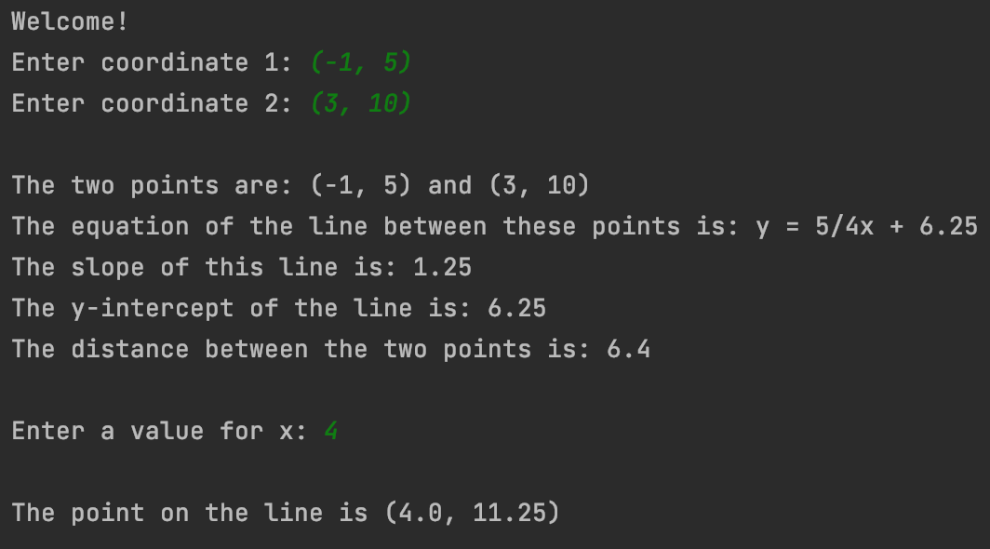

**Full Program Example 2: User enters decimal value for x**

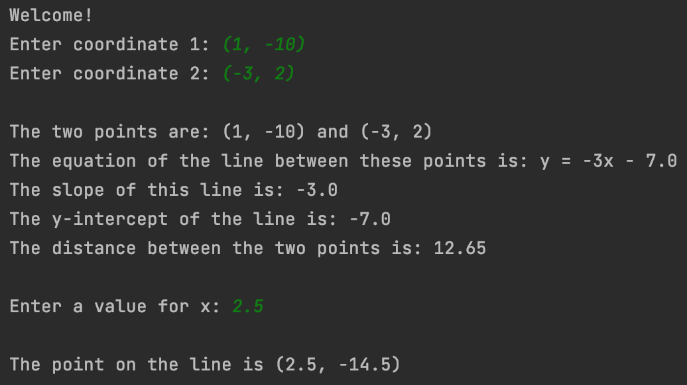

**Full Program Example 3: User enters two points that are on a vertical line**

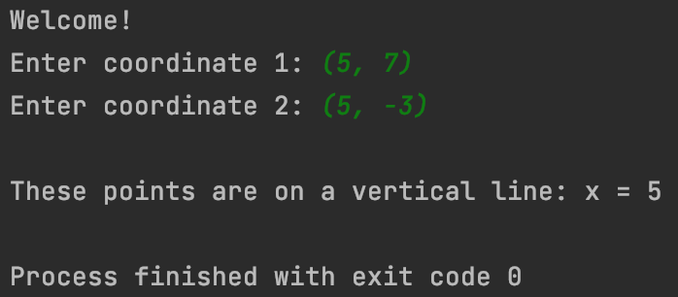

**Test values to use for testing the equation(), slope(), yIntercept(), distance(), lineInfo(), and coordinateForX(double) methods of your LinearEquation class:**

**Sample test code to help you test your LinearEquation methods:**

int x1 = -1;

int y1 = 5;

int x2 = 3;

int y2 = 10;

LinearEquation equation = new LinearEquation(x1, y1, x2, y2);

System.out.println("Equation: " + equation.equation());

System.out.println("Slope: " + equation.slope());

System.out.println("y-intercept: " + equation.yIntercept());

System.out.println("Distance: " + equation.distance());

System.out.println();

System.out.println("----- Line info -----");

System.out.println(equation.lineInfo());

System.out.println();

double testX = 4;

System.out.println("Coordinate for x: " + equation.coordinateForX(testX));

**OUTPUT for the test case above:**

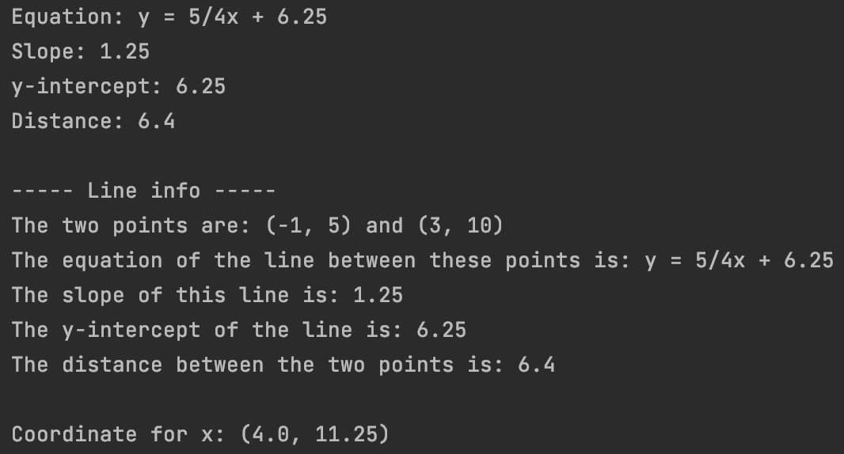

**Additional test points and the expected returned String from lineInfo() for each:**

**Test Case 1: Positive fractional slope (this test case shown above)**

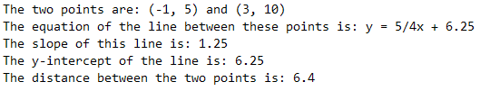

**Test Case 2: Positive fractional slope**

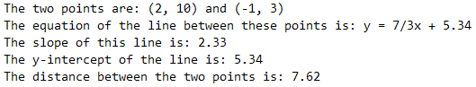

**Test Case 3: Positive fractional slope, negative y-intercept**

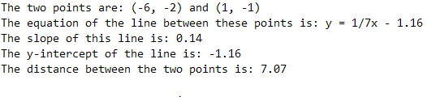

**Test Case 4: Positive fractional slope**

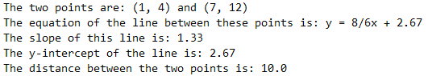

**Test Case 5: Positive fractional slope, y-intercept = 0 (not printed)**

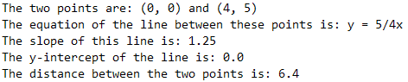

**Test Case 6: Negative fractional slope**

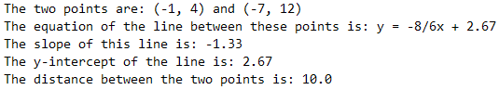

**Test Case 7: Negative fractional slope**

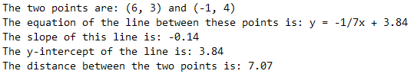

**Test Case 8: Whole number positive slope, negative y-intercept**

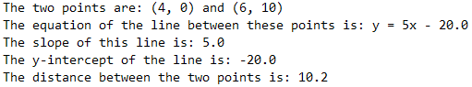

**Test Case 9: Whole number negative slope**

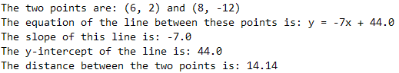

**Test Case 10: Whole number negative slope, negative y-intercept**

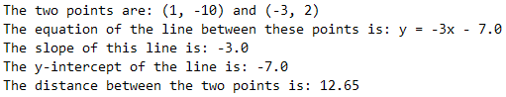

**Test Case 11: Whole number positive slope, y-intercept = 0 (not printed)**

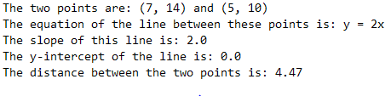

**Test Case 12: Slope of +1 (the 1 not printed)**

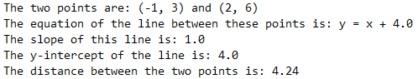

**Test Case 13: Slope of -1 (only a negative sign is printed)**

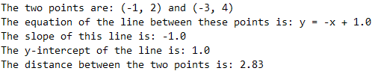

**Test Case 14: Line with slope of 1 through origin (y = x)**

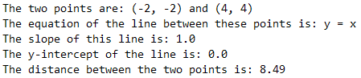

**Test Case 15: Horizontal line (slope = 0), positive y-intercept**

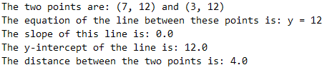

**Test Case 16: Horizontal line (slope = 0), negative y-intercept**

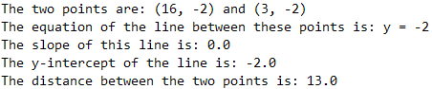

**Checklist & Rubric (20 points; half point for each row)**

| **#** | **Program Technical Requirement** | **Self check**  **X** | **Mr. Miller’s check** |
| --- | --- | --- | --- |
| **Design** | | | |
| 1 | All method names and signatures match those in the specifications; i.e. don’t change method names, parameter types, or return values from the requirements |  |  |
| 2 | Code has proper indentation, use of well-named variables, blank spaces as appropriate to break up sections of code, and comments to explain complex design. |  |  |
| **The LinearEquationRunner client class** | | | |
| 3 | In the main() method, the program welcomes the user. |  |  |
| 4 | Program uses the Scanner class to accept two different coordinates and store them as String variables. |  |  |
| 5 | Both coordinates are accepted and saved in the format “(x, y)” |  |  |
| 6 | Successfully use string methods to extract x and y from each point |  |  |
| 7 | Successfully use Integer.parseInt to convert string values to int values |  |  |
| 8 | Program checks to see if x1 == x2 before creating a LinearEquation object. |  |  |
| 9 | If user enters two points with the same x value (i.e. a vertical line), the program informs the user a message that the line is a vertical and outputs the equation of the line in x = ___ format, e.g. "x = 4" and the program ends. |  |  |
| 10 | Program generates a LinearEquation object from the x and y values parsed from the coordinates, i.e. x1, y1, x2, y2 |  |  |
| 11 | Program uses System.out.println(obj.lineInfo()), where obj is your LinearEquation object, to print the LinearEquation object’s info. |  |  |
| 12 | After line’s information is printed, the program asks user to enter an x value |  |  |
| 13 | The program accepts an x value from the user as a double |  |  |
| 14 | The program uses the LinearEquation object's coordinateForX method to obtain the String coordinate. |  |  |
| 15 | The program prints the resulting String coordinate for the user. |  |  |
| 17 | **All** printed decimal values are rounded to the nearest *hundredth*. |  |  |
| **The LinearEquation class** | | | |
| 17 | public LinearEquation(int x1, int y1, int x2, int y2) constructor creates a LinearEquation object. |  |  |
| 18 | public double distance() correctly calculates and returns distance between (x1, y1) and (x2, y2) |  |  |
| 19 | public double yIntercept() correctly calculates and returns the y-intercept of the line between (x1, y1) and (x2, y2) |  |  |
| 20 | public double slope() correctly calculates and returns the slope of the line between (x1, y1) and (x2, y2) |  |  |
| 21 | public String equation() correctly returns a String that represents the linear equation of the line through points (x1, y1) and (x2, y2) in slope-intercept (y = mx + b) form, where m is the "printable" slope and b is the y-intercept; e.g. "y = 3x + 1.5" |  |  |
| 22 | * printed slope is a whole number when the fraction reduces to a whole number (e.g. "4" instead of "8/2") |  |  |
| 23 | * printed slope is a fraction when it can’t be reduced to a whole number (e.g. "4/3") |  |  |
| 24 | * printed negative slopes have the negative sign in the correct place (e.g. "-4/3", ***not*** "4/-3") |  |  |
| 25 | * no "double negatives" appear in the printed slop (e.g. "4/3", ***not*** "-4/-3") |  |  |
| 26 | * correctly prints slopes of +1 and -1 (e.g. "y = x + 4.0" and "y = -x + 4.0", ***not*** y = "1x + 4.0" or "y = -1x + 4.0" |  |  |
| 27 | * printed y-intercepts are rounded to two decimal places. |  |  |
| 28 | * printed y-intercepts are not shown for a y-intercept of 0. |  |  |
| 29 | * printed negative y-intercepts appear as subtraction rather than plus a negative (e.g. "y = 2x - 4.0" and "y = 1/2x - 7.25", ***not*** y = "2x + -4.0" or "y = 1/2x + -7.25" |  |  |
| 30 | public String equation() handles horizontal lines (when *m* = 0, i.e. when y1 and y2 are equal) by returning an equation in the form *y = b*; for example, the line through points (2, 5) and (7, 5) should be returned as "y = 5" rather than "y = 0x + 5" |  |  |
| 31 | public String lineInfo() correctly generates and returns a printable String outputting all required information. |  |  |
| 32 | * Includes the original points: (x1, y1) and (x2, y2) |  |  |
| 33 | * The equation of the line in y = mx + b format (generated by calling the equation() method) |  |  |
| 34 | * The slope of the line, as a decimal (using slope() method) |  |  |
| 35 | * The y-intercept of the line (using yIntercept() method) |  |  |
| 36 | * The distance between the two points (using distance() method) |  |  |
| 37 | public String coordinateForX(double yValue) correctly computes the corresponding y value for the point on the line and returns a string representing the coordinate for the point (x, y) with values rounded to the nearest hundredth, e.g. (4.5, -1.27) |  |  |
| 38 | public double roundedToHundredth(double toRound)correctly returns the toRound value rounded to the nearest *hundredth.* |  |  |
| 39 | roundedToHundredth(double toRound) are used appropriately in your other methods so as to reduce redundancy |  |  |
| **Testing and submission** | | | |
| 40 | All 16 test cases are tested (including others you think up) to ensure accuracy in your method development. |  |  |
|  | **Rubric Row Total (out of 40)** |  |  |
|  | **Total Points (out of 20; 0.5 points per row)** |  |  |